**Task 1:-**

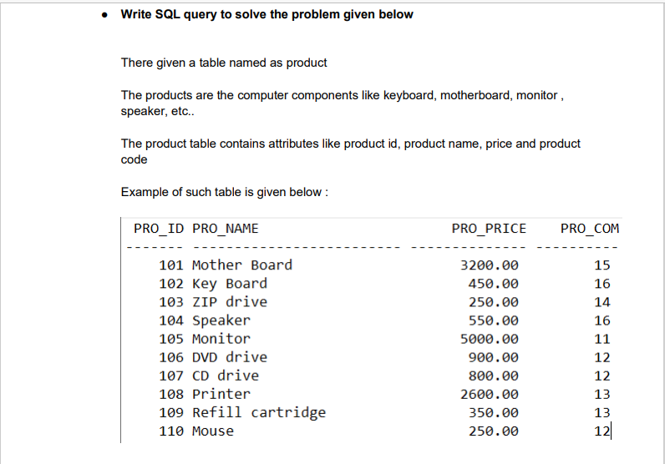

**Ans:**

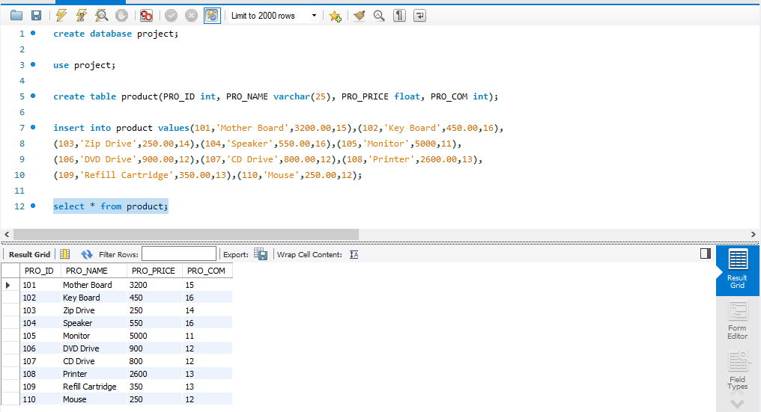

**Task-2:** Write sql query to find the items whose prices are higher than or equal 250rs. Order the result by product price in descending, then product name in ascending. Return pro_name and pro_price.

**Ans:**

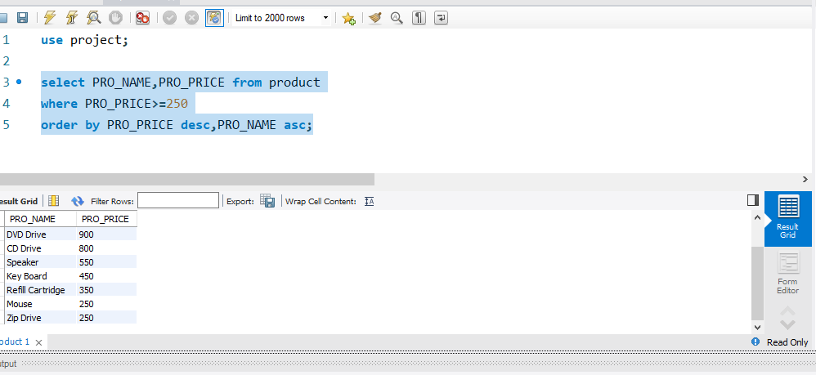

**Task-3:** Write a sql query to find the cheapest item. Return pro_name and pro_price.

**Ans:**

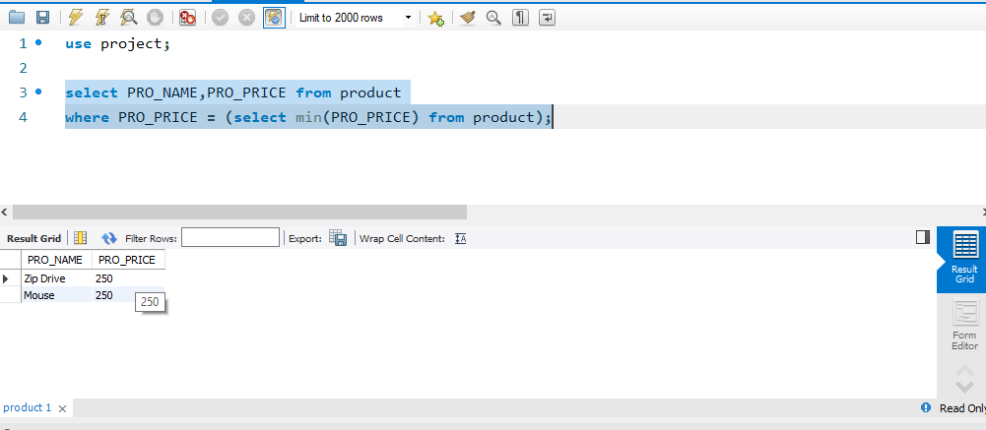

**Task-4:** Write the sql query to calculate the average price of the items. Return average price and product id.

**Ans:**

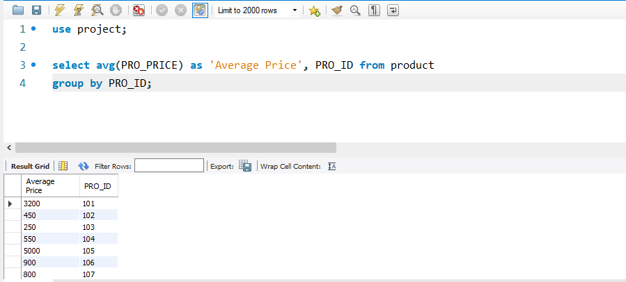

**Task-5:** Write the sql query to find the total for all the product mention in the table.

**Ans:**

